Hey there Dr.Cardon,

Been a while since the last update, so apologies for going off the grid. I have been working on Bigger Fish however in between several job interviews and work, so again apologies, these are stressful times. It’s been a bit demoralizing as when I tried to implement the hostile AI for dolphins the game just broke. I have since removed them and diverted my efforts to other parts of the project in the meantime, while I try to figure out a way through the bug and implement them properly. After that, it should be an easy segway into other hostile AI including the Boss Megalodon intended for the Final Demo.

So it’s the last week and I have constructed a plan to get a demo out by August 8th and set by your due date. I plan on having the demo revolve around starting as a young White Shark and eating other creatures while avoiding dolphins and other bigger fish to grow to be able to eat them and become the apex predator that can take on the king of the ocean, the Megalodon. This demo is just to get a flavor of what I have for the game while still giving a fully playable experience. I don’t expect it to be perfect as I have discovered making a game with AI and a fully three dimensional scale is very difficult, but I expect it to be worthy of my premise for early semester.

Plan up to August 8:

1. Fix hostile AI and implement Dolphin and Megalodon Boss
2. Hitbox and physics optimization
3. Basic UI and menus

So what have I been working on? Recently I have completed and still adjusting the growth and hunger system of Bigger Fish, which was quite a big task. You start as a scaled down game object of the white shark with a fraction of health and damage that an adult would be or have. Overtime,unless you are starved, you will grow automatically and that amount of time can be accelerated by feeding on other dead animals and regaining energy. The more you eat, the faster you will grow! I have constructed some very basic UI elements to represent these states in Photoshop here:



The process of growth will stop when the shark hits their maximum scale, damage and health, which is currently being tested to be the most realistic and fun for the demo. Here is a screenshot of the White Shark full grown in the current build:

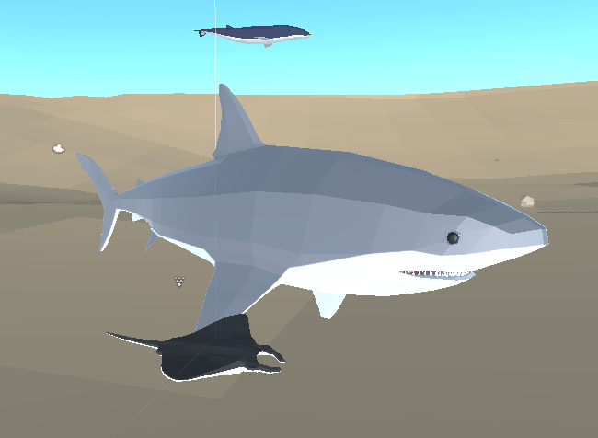

So all my focus is being dedicated to Bigger Fish this week and I hope to even wrap up and bring you a demo before August 8th. The biggest task is still the hostile AI, but once that wraps up, everything else will be optimizations and UI changes and updates. I hope you’ve been doing well this summer and staying safe. Let me know what you think and anything else I can do.

Thank you!

Evan Frisbie